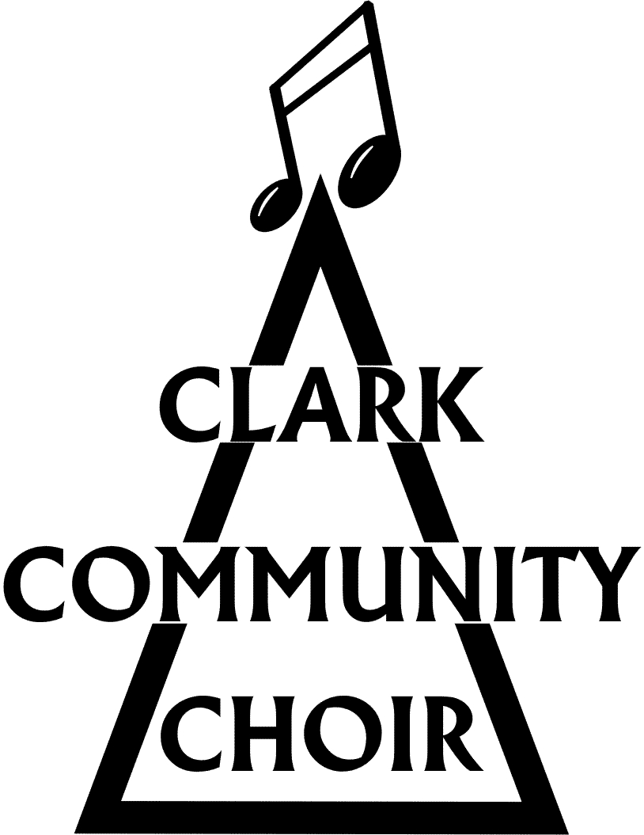
THE CLARK COMMUNITY CHOIR

CODE OF CONDUCT

We are fully committed to safeguarding the welfare of all members of our choir. Members should, at all times, show respect and understanding for the rights of everyone else, and their safety and welfare, and conduct themselves in a way that reflects our principles.

Membership:
- Membership of the choir is open to any individuals living in Musselburgh and its surrounding areas. Individuals under the age of 16 should be accompanied by a responsible adult at all times.
- Membership to the choir does not require a formal singing audition.
- There is no minimum requirement on the number of rehearsals members are required to attend. Regular attendance is though encouraged, especially in the run up to important events.

Respect:
- Members are expected to show respect to each other, the choir conductor, and any other volunteers associated with the choir. This includes refraining from any discriminatory or abusive language or behaviour, and treating others with kindness and consideration.
- Members are expected to avoid causing discomfort to others at any time.
- Every member of the CCC has a right to participate in the choir regardless of musical ability or previous musical experience and should be able to participate without fear of judgement.

Privacy:
- Members are expected to treat others’ personal and identifying information such as names, photos and contact details with confidentiality, unless the person concerned has agreed their details can be shared. Consent must be explicit and not assumed.

Safety:
- Members are expected to prioritise safety at all times during rehearsals, performances, and other choir events, and to follow any safety guidelines or instructions provided by the choir director or other staff.
- Members should only attend rehearsals and choir events if they are fit and well. If you have a medical condition which may affect you whilst out with the choir, then please make our safeguarding contact aware. This information will be treated in the strictest confidence, in compliance with our data protection policy.

This code of conduct relates to every part of the Clark Community Choir, including weekly rehearsals; one-off events and performances; the mailing list and the Facebook group.
Failure to adhere to these expectations may result in a member being asked to leave the choir.
If you have any concerns about the behaviour of another member then please speak to the chairperson or another committee member if they are not available.

The Clark Community Choir is a registered Scottish Charity No. SCO41855

