**THE CLARK COMMUNITY CHOIR**

**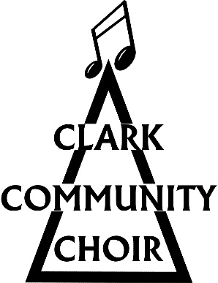  
Data protection policy**

In order to operate the Clark Community Choir (CCC) needs to gather, store and use certain forms of information about individuals.

The CCC processes personal information (email addresses and phone numbers) of individuals attending choir sessions and who consent to the organisation doing so.

The information will be used to inform members about choir events and occasional other relevant singing activities. Choir members can join our private Facebook page or Whatsapp group to receive information if they wish and give their consent.

The CCC takes photographs and videos of members taking part in choir events. These are used for publicity on the choir website, posters and social media. Members are asked for their consent for photos and videos to be shared in this way and have the opportunity to refuse consent or to withdraw consent at any time.

The CCC processes the information in accordance with the Data Protection Act 2018 and the principles of GDPR in the following ways:

* **Lawfulness, fairness and transparency**A clearly written privacy notice will be written on the registration form that new members are asked to sign when they give their contact details and indicate consent to the use of photos and videos. Data will only be used for the purposes described.
* **Adequate, relevant and limited to what is necessary**The information collected will only be what is necessary for the running of the organisation, for establishing and maintaining membership of the choir. No information other than contact details shall be collected. The information will not be shared with any 3rd party without permission and only shared within the choir on a strict need to know basis.
* **Accurate and up to date**All reasonable steps will be taken to ensure that the information is accurate. The email list will be updated regularly. Choir members are required to fill in new registration forms each year and a new membership list created from this. Older information is then deleted. Any inaccuracies will be rectified as soon as possible.
* **Only hold the information for as long as is necessary**The list will be updated regularly (see above).
* **Appropriate control and choice**The privacy notice on the consent form will make it clear that choir members can withdraw consent for us to hold any information they give us at any time.
* **Security**Personal data will be held on a password protected computer. Only a few members of the committee have access to this computer.

All rights of data subjects under the Data Protection Act 2018 and the EU General Data Protection Regulation (GDPR) will be respected.

* **Right of access**Choir members have a right to access the information held about them free of charge. We will respond to such requests as soon as possible and at the latest within one month of the request.
* **Right of erasure**Choir members have a right to ask for all information held about them to be erased. We will respond to such requests as soon as possible and at the latest within one month of the request.
* **Right to complain**Choir members have a right to complain to the Information Commissioner’s Office if they think that there is a problem with the way their data has been handled.

The Information Commissioner’s Office – Scotland  
Queen Elizabeth House  
Sibbald Walk  
Edinburgh  
EH8 8FT

Telephone: 0303 123 1115

Email: [Scotland@ico.org.uk](mailto:Scotland@ico.org.uk)