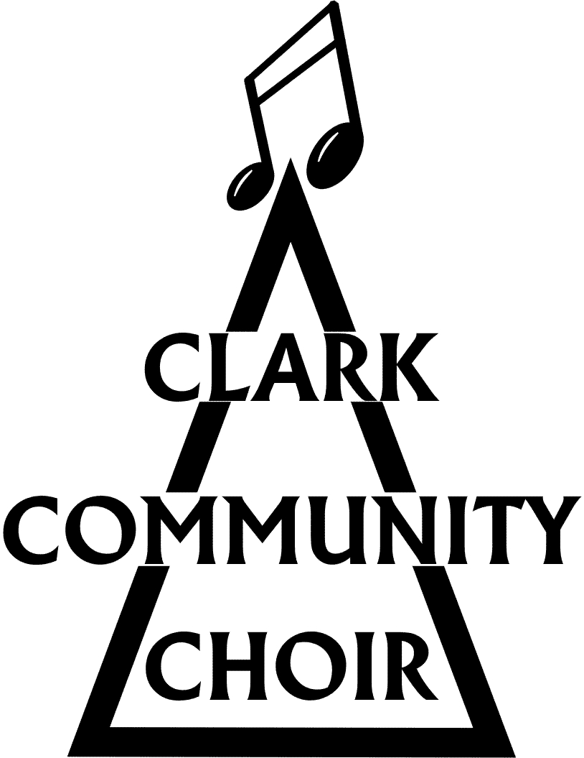
THE CLARK COMMUNITY CHOIR

Roles of trustees

The Clark community Choir (CCC) is a not for profit organisation run by volunteers. No one receives any monetary compensation for their duties. The roles of trustees are taken by the choir committee members. The committee of the CCC should not exceed 15 persons. They shall meet on a regular basis, at least six times a year, to manage the affairs of the CCC. Should a meeting not be scheduled for some time and an emergency situation arises which requires immediate decision, this may be made by three out of the four office bearers. In the event of a tie, the casting vote to be made by the Chairperson. The quorum for all meetings of the committee shall be at least fifty per cent of their number.
A committee member shall be deemed to have resigned either if they have failed to attend a single meeting in one year or shown no interest in the affairs of the CCC for some time.
There are 4 office bearer positions in the committee:
Chairperson
Vice Chairperson
Treasurer
Secretary

Office bearers are elected annually by members at the AGM. An outline of their duties is detailed below:

Chairperson
The chairperson should welcome people at the start of every rehearsal and be a point of contact for member queries. It is the chairperson’s responsibility to help aid the smooth running of the choir.
The chairperson will chair committee and wider choir member meetings.
There are some duties which need to be carried out at specific points during the year:
January - Chairpersons report to treasurer. Books submitted to accountant.
February- Strato (website) payment due. AGM prep- send constitution, chairpersons report, accounts and agenda to secretary for dissemination to members.
At AGM- Present the chairpersons report and agree accounts.
After AGM - Send account report, chair report & confirmation to OSCR.

Vice Chairperson
The vice-chairperson should be available to step in and take over duties should the chairperson not be available. The vice-chairperson should be available to assist the chairperson with their duties.
During the AGM the vice-chairperson will be responsible for leading the election of the chairperson.

Treasurer
It is the role of the treasurer to manage the finances of the CCC.
This includes:
Receiving all monies collected at practice and from fundraising.
Depositing all monies collected into the bank.
Organising payment of all outgoings.
Keep choir accounts / spreadsheets up to date and in order.
Collate all finance documents and arrange drop off at approved Accountant.
Collect accountants report for approval at AGM and return for sign off.

Secretary
Duties include:
Taking minutes of committee meetings. These minutes should be put on the choir website once approved by the rest of the committee members.
Putting the agenda together for meetings and circulate this to committee members prior to meetings.
Collating choir registration forms and contact information. The secretary should ensure this information is up to date.
Ensuring the choir complies with current GDPR legislation.
Emailing AGM information and paperwork to members.

Non-office bearing committee members
Committee members are expected to attend meetings and rehearsals on a regular basis. They are expected to support the work of the office bearers and help with the running of the choir.
Roles within the committee which people can be involved in:
Organising tea time and collecting money at rehearsals.
Welcoming and mentoring new members.
Updating of the choir website.
Keeping our social media channels updated.
Completing fundraising and grant applications.
Applying for appropriate licenses, as needed, for busking.
Helping organise venues, transport and accommodation for performances.
Be available to support members in their choir section in learning of song parts.
Advertising choir events.
Putting together press releases to promote choir in the wider community.

In addition to the above, there will be a named point of contact for safeguarding.

