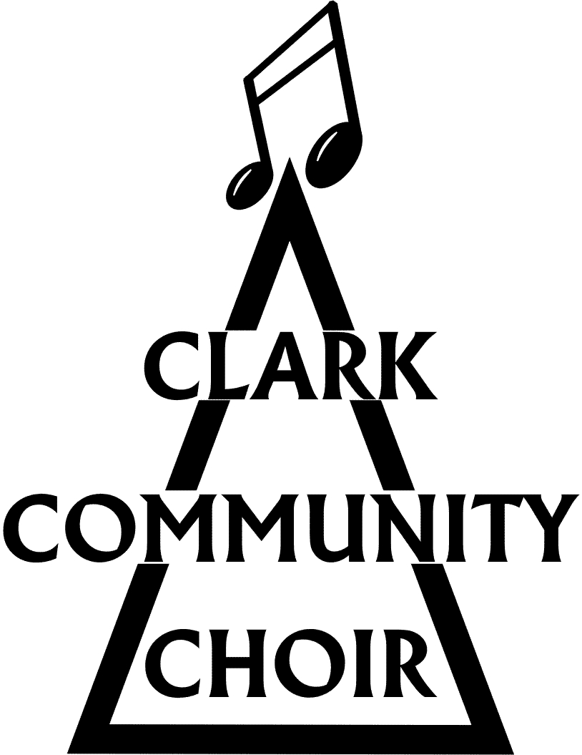
THE CLARK COMMUNITY CHOIR

Safeguarding Policy

The law requires any organisation involving young people and vulnerable adults to take all reasonable measures to ensure that the risk of harm to their welfare is minimised and, where there are concerns, to share them with other agencies, as appropriate.
The Clark Community Choir recognises that it is not the role of our organisation to decide whether a child or vulnerable adult has been abused or not. This is the role of the Social Services department who have legal responsibility or the NSPCC who have powers to investigate child protection concerns under the Children Act.
For the purposes of this policy, anyone up to the age of 18 is a child and anyone over 18 years who is or may be unable to take care of themselves or unable to protect themselves against significant harm or exploitation is a vulnerable adult.
The Clark Community Choir generally comprises members who are independent adults but occasionally we may be joined by children (generally children of choir members), and possibly vulnerable adults, who may rehearse and/or perform with us. We recognise the need to safeguard any young and vulnerable members and the Committee has therefore adopted the following Safeguarding Policy.
How The Clark Community Choir operates
The CCC is a registered charity of amateur singers managed by a committee of volunteers elected at the annual general meeting or co-opted as necessary. Committee members are trustees of the charity. To carry out its charitable objectives we perform in our local community care homes, guilds and local community events. We present a few larger public concerts a year, sometimes performing with other choirs. Rehearsals are run by our volunteer musical director. There are no employed staff or volunteers in the conventional sense. From time to time CCC organises other events such as choral workshops and social events.
CCC does not advertise itself as an activity solely suitable for children, young people or vulnerable adults. Most choir members are independent adults and generally there are only a few young people (under 18) who rehearse and perform with the choir. Choir rehearsals and performances are group activities, and there is no need for a member of the choir to be alone with another member of any age. CCC is therefore unlikely to be targeted by a person seeking opportunities to abuse children or vulnerable adults. Nevertheless, CCC recognises its responsibility to safeguard the welfare of children and vulnerable adults with whom it works and comes into contact, and believes that everyone has the right to enjoy the activities of the choir in a happy, safe and secure environment.
Guidelines
Membership - Should any child or close relative (under 16) of a member of CCC participate in choral works with CCC the member must act as a responsible adult. Should any other child/young person participate in any CCC activities they must be accompanied by a parent or other responsible adult who remains responsible for them throughout rehearsals and performances.
Audiences and Social Events - CCC is aware that children and vulnerable adults may attend their concerts as members of the audience, or attend social functions hosted by CCC. It is the responsibility of the parent, guardian or carer to ensure adequate supervision. If a parent/guardian/carer is not personally attending an event this policy requires them to be satisfied that the child or vulnerable adult will be accompanied and adequately supervised by a responsible adult acting on their behalf at all times.
Privacy - Parents and guardians should be aware that photography, audio and video recording are undertaken from time to time at concerts and rehearsals. The images and recordings are used both on- and off- line including on the web. They provide valuable tools to promote the work of the choir to a wider audience and form part of the historical record of our work.
Abuse - CCC endeavours by the implentation of this safeguarding policy to protect and minimise the risks of abuse of children, young people and vulnerable adults. The term child abuse is used to describe a range of ways that people harm children. Abuse of adults can happen anywhere. It can happen at home, in a residential or nursing home, in a hospital, at work or in the street. There are four main categories of abuse namely physical, sexual, emotional abuse and neglect. CCC notes the importance of being alert to signals of abuse and to the difficulty children or vulnerable adults may have in reporting it.
Implementation of this policy
- The CCC committee have nominated Kirsty Robertson as the Designated Person in respect of Safeguarding. The Designated Person shall undertake appropriate training as required and will be identified to children and vulnerable adults as the principal person they should turn to if they have any concerns or queries. Contact details for the Designated Person are given on the members section of the website.
- Any concerns regarding either, a child or a choir member, volunteer or other adult must immediately be reported to the Designated Person (or in his or her absence to the Chair of the Committee).
Designated person for safeguarding- Kirsty Robertson (April 2025)

The Clark Community Choir is a registered Scottish Charity No. SCO41855

